SDRAM PARAMETER CONTROLLER:
CODE:
`timescale 1ns/1ps
module sdram_parameter_controller (
input wire clk,
input wire reset,
input wire read,
input wire write,
input wire sleep, // sleep mode request
input wire pwr_good, // power status from power gating
input wire [3:0] addr,
input wire [7:0] wdata,
output reg [7:0] rdata,
output reg ready,
// Memory interface
output reg mem_we,
output reg [3:0] mem_addr,
output reg [7:0] mem_wdata,
input wire [7:0] mem_rdata,
// Power status outputs
output wire idle,
output wire clk_gated,
output wire mem_enable,
output wire pwr_gate
);
// State Definition
reg [2:0] state;
parameter IDLE = 3'b000;
parameter ACTIVATE = 3'b001;
parameter READ_CMD = 3'b010;
parameter WRITE_CMD = 3'b011;
parameter PRECHARGE = 3'b100;
// Idle Detection
assign idle = ~(read | write);
// Clock Gating
wire clk_en;
assign clk_en = ~sleep & ~idle;
assign clk_gated = clk & clk_en;
// Memory Block Enable
assign mem_enable = ~sleep;
// Power Gating Control
assign pwr_gate = sleep & idle;
// FSM Logic
always @(posedge clk_gated or posedge reset) begin
if (reset) begin
state <= IDLE;
ready <= 1'b0;
mem_we <= 1'b0;
mem_addr <= 4'b0000;
mem_wdata <= 8'b00000000;
rdata <= 8'b00000000;
end
else if (mem_enable & pwr_good) begin
case(state)
// IDLE
IDLE: begin
ready <= 1'b0;
if (read || write) begin
mem_addr <= addr;
state <= ACTIVATE;
end
end
// ACTIVATE
ACTIVATE: begin
if (read)
state <= READ_CMD;
else if (write)
state <= WRITE_CMD;
end
// READ
READ_CMD: begin
mem_we <= 1'b0;
rdata <= mem_rdata;
state <= PRECHARGE;
end
// WRITE
WRITE_CMD: begin
mem_we <= 1'b1;
mem_wdata <= wdata;
state <= PRECHARGE;
end
// PRECHARGE
PRECHARGE: begin
ready <= 1'b1;
mem_we <= 1'b0;
state <= IDLE;
end
default: begin
state <= IDLE;
end
endcase
end
end
endmodule

TEST BENCH CODE:
`timescale 1ns/1ps
module tb_sdram_controller;
// Testbench signals
reg clk;
reg reset;
reg read;
reg write;
reg sleep;
reg pwr_good;
reg [3:0] addr;
reg [7:0] wdata;
wire [7:0] rdata;
wire ready;
wire mem_we;
wire [3:0] mem_addr;
wire [7:0] mem_wdata;
reg [7:0] mem_rdata;
wire idle;
wire clk_gated;
wire mem_enable;
wire pwr_gate;
// Instantiate SDRAM Controller
sdram_controller uut (
.clk(clk),
.reset(reset),
.read(read),
.write(write),
.sleep(sleep),
.pwr_good(pwr_good),
.addr(addr),
.wdata(wdata),
.rdata(rdata),
.ready(ready),
.mem_we(mem_we),
.mem_addr(mem_addr),
.mem_wdata(mem_wdata),
.mem_rdata(mem_rdata),
.idle(idle),
.clk_gated(clk_gated),
.mem_enable(mem_enable),
.pwr_gate(pwr_gate)
);
// Clock generation
initial begin
clk = 0;
forever #5 clk = ~clk; // 10ns clock
end
// Simple memory model
reg [7:0] memory [0:15];
always @(posedge clk) begin
if(mem_we)
memory[mem_addr] <= mem_wdata;
mem_rdata <= memory[mem_addr];
end
// Test sequence
initial begin
$display("Starting Low Power SDRAM Controller Test");

reset = 1;
read = 0;
write = 0;
sleep = 0;
pwr_good = 1;
addr = 0;
wdata = 0;
#20 reset = 0;
// WRITE operation
#10;
write = 1;
addr = 4'h5;
wdata = 8'hAA;
#10;
write = 0;
// READ operation
#10;
read = 1;
#10;
read = 0;
$display("Read Data = %h", rdata);
// IDLE test
#20;
$display("Idle state = %b", idle);
// Sleep mode test
sleep = 1;
#20;
$display("Power Gate = %b", pwr_gate);
// Wake up from sleep
sleep = 0;

#10;
write = 1;
addr = 4'h3;
wdata = 8'h55;
#10;
write = 0;
// READ again
#10;
read = 1;
#10;
read = 0;
$display("Read Data = %h", rdata);
// Finish simulation
#50;
$display("Simulation Finished");
$finish;
end
endmodule

SCHEMATIC:
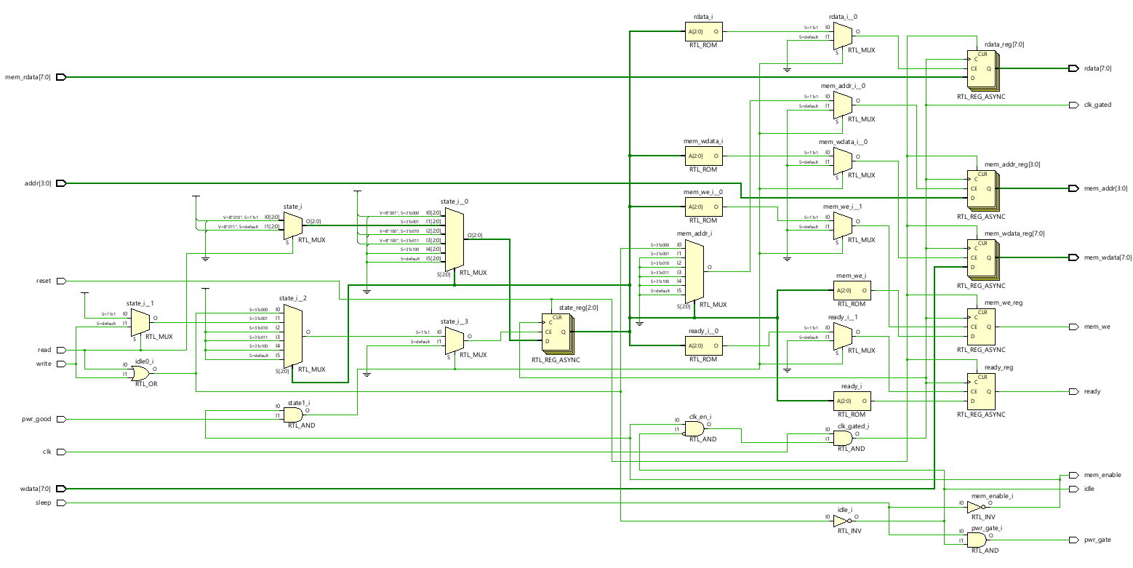
SIMULATION:
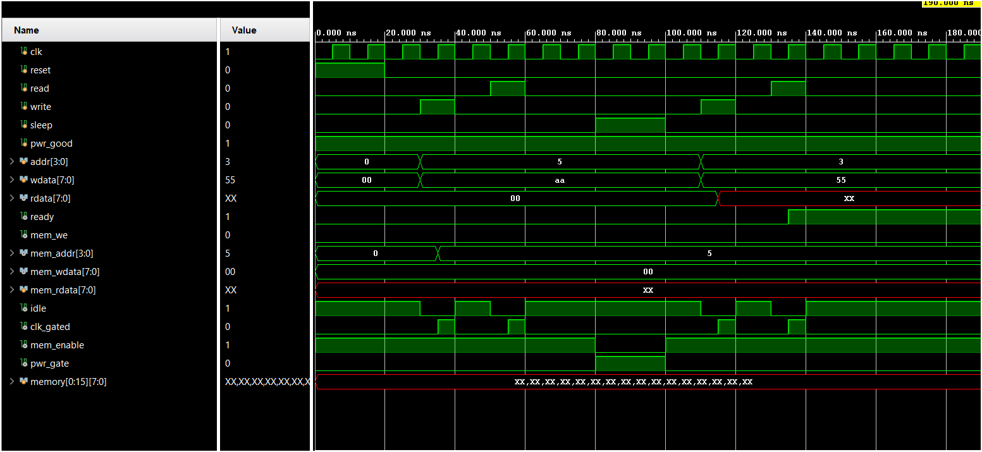

POWER: 1.471 W

